REST API Testing:

Inserting User:

Registering the new user, if not already exists remember here there is no checks on email and password.

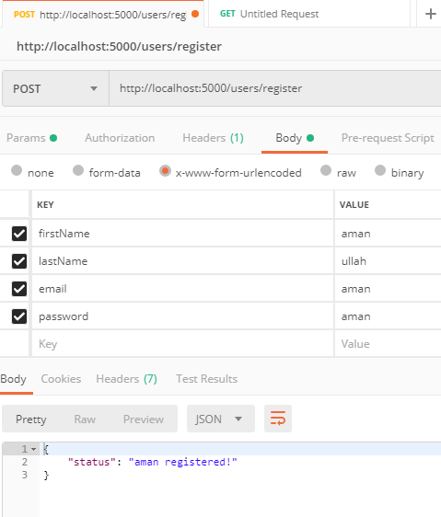

Registering same user multiple time gives an message that user already exist so not storing in database second time.

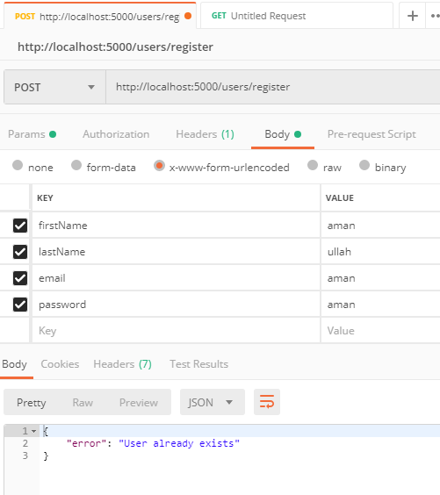

**Login USER:**

The output display is a Token.

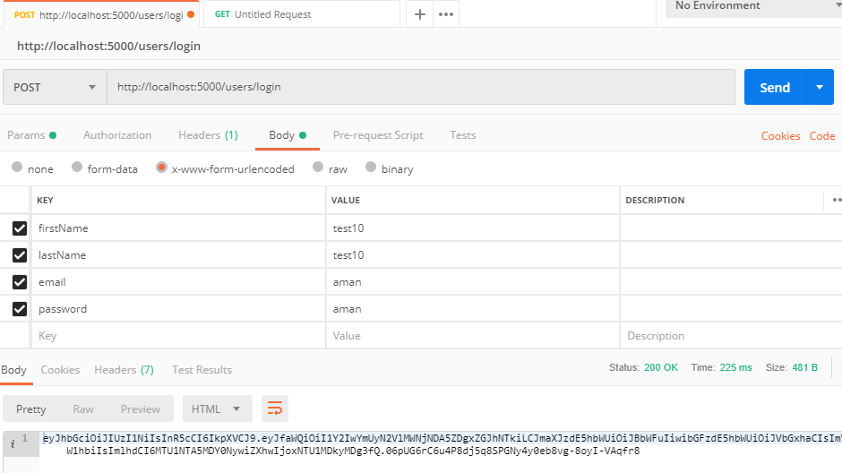

Without tokenizing the users detail the original of user.

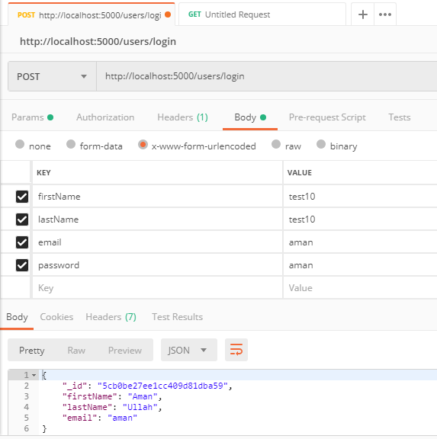

**Updating User:**

Only updating the first and last name by comparing email of user.

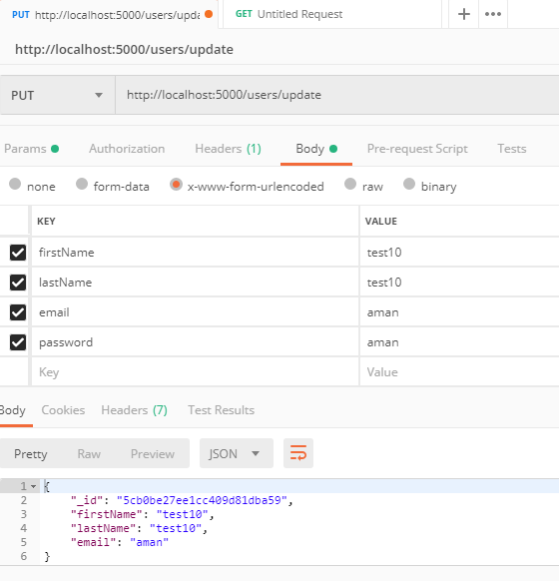

**Deleting User:**

Deleting user simply by comparing the email

